Lab#14 Create a quiz application that displays one question at a time. Track the user's score and show the final result at the end.

TAGS USED | DESCRIPTION
<!DOCTYPE html> | Declares the document as an HTML5 document.
<html> | Root element of the HTML document.
<head> | Contains metadata and information about the HTML document.
<title> | Specifies the title shown in the browser tab.
<style> | Defines the CSS styles used to design the webpage.
<body> | Contains all visible content of the webpage.
<div> | Groups related elements together in a container.
<h2> | Displays the main heading, "Quiz Application".
<h3> | Displays the current question and final score.
<p> | Displays the answer result and final percentage.
<button> | Creates clickable buttons for answer options, the next question, and restarting the quiz.
<script> | Contains JavaScript code to control the quiz functionality.
const | Declares a constant variable to store the quiz questions and answers.
let | Declares variables whose values can change, such as the current question and score.
function | Defines reusable blocks of JavaScript code.
forEach() | Iterates through the answer options to create buttons.
if...else | Checks whether the selected answer is correct or incorrect.
document.getElementById() | Selects an HTML element using its ID.
document.querySelector() | Selects the first HTML element matching the specified CSS selector.
document.querySelectorAll() | Selects all elements matching the specified CSS selector.
innerHTML | Gets or changes the HTML content of an element.
onclick | Executes a JavaScript function when a button is clicked.
style | Applies inline CSS styling to an HTML element.
disabled | Prevents users from clicking answer buttons after answering a question.
class | Assigns a class name to an HTML element for styling and selection.
id | Assigns a unique identifier to an HTML element.
margin | Sets the space outside an element.
padding | Sets the space inside an element.
background-color | Sets the background color of an element.
color | Sets the text color.
font-family | Specifies the font used for the text.
text-align | Aligns text horizontally.
border-radius | Rounds the corners of an element.
cursor | Specifies the mouse cursor appearance.
:hover | Applies CSS styles when the mouse pointer moves over an element.

Final Outcome:

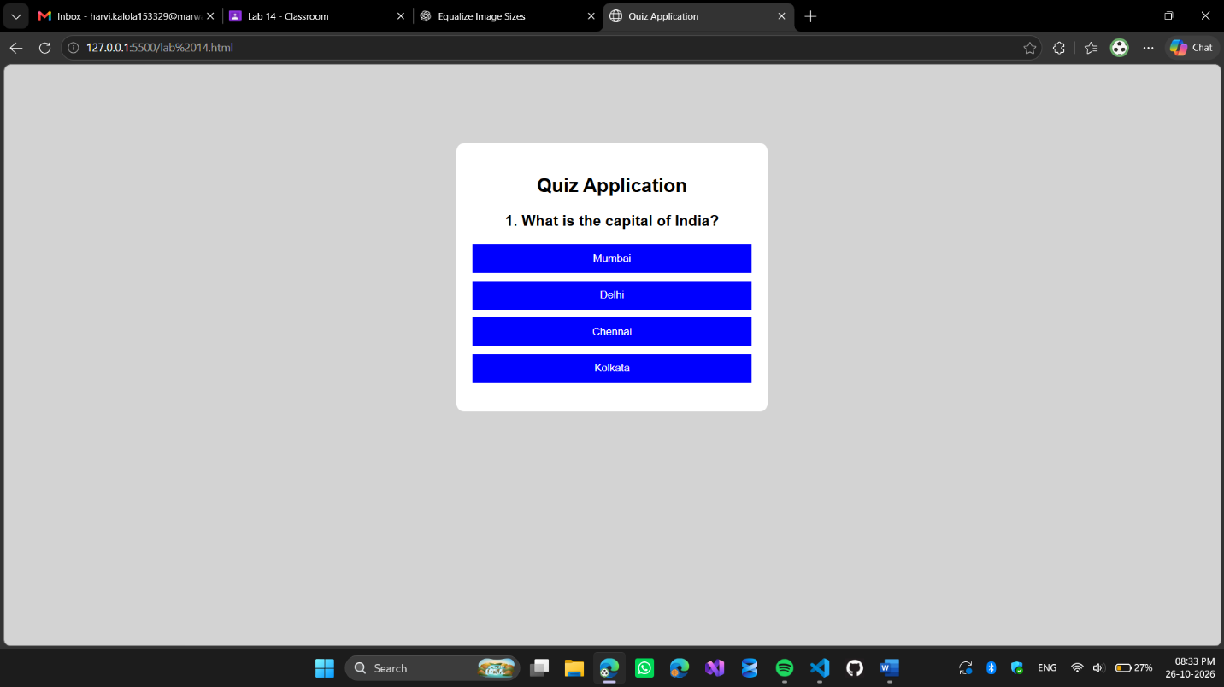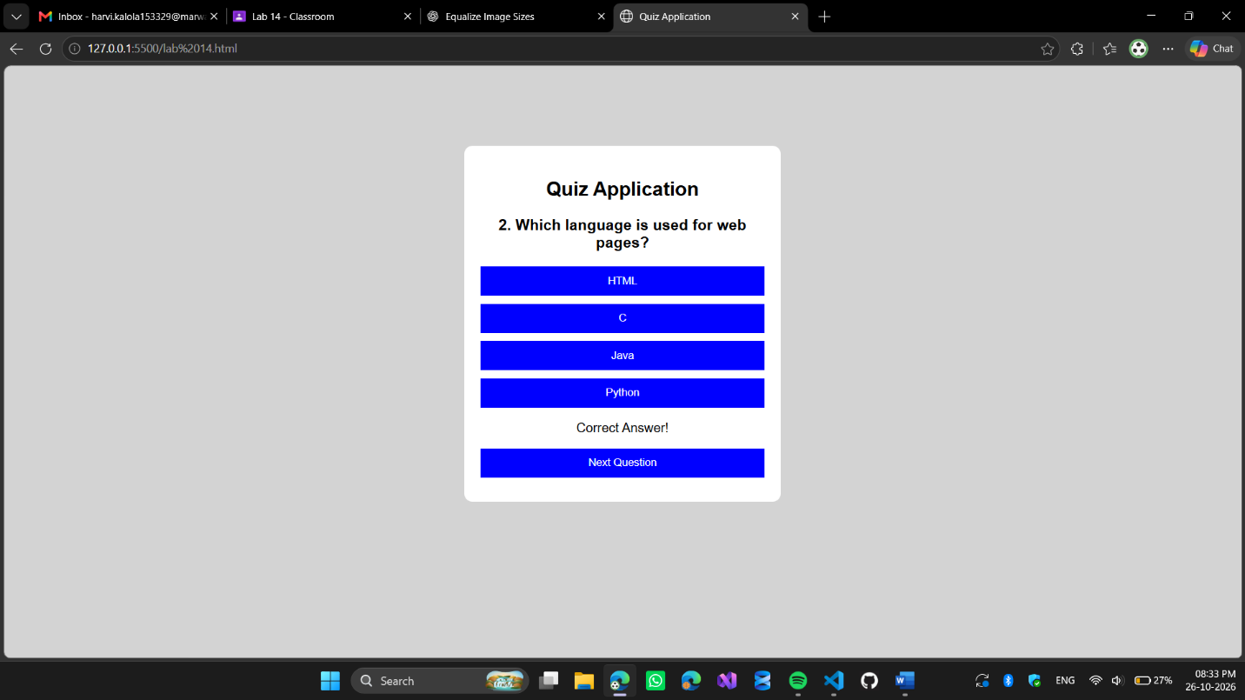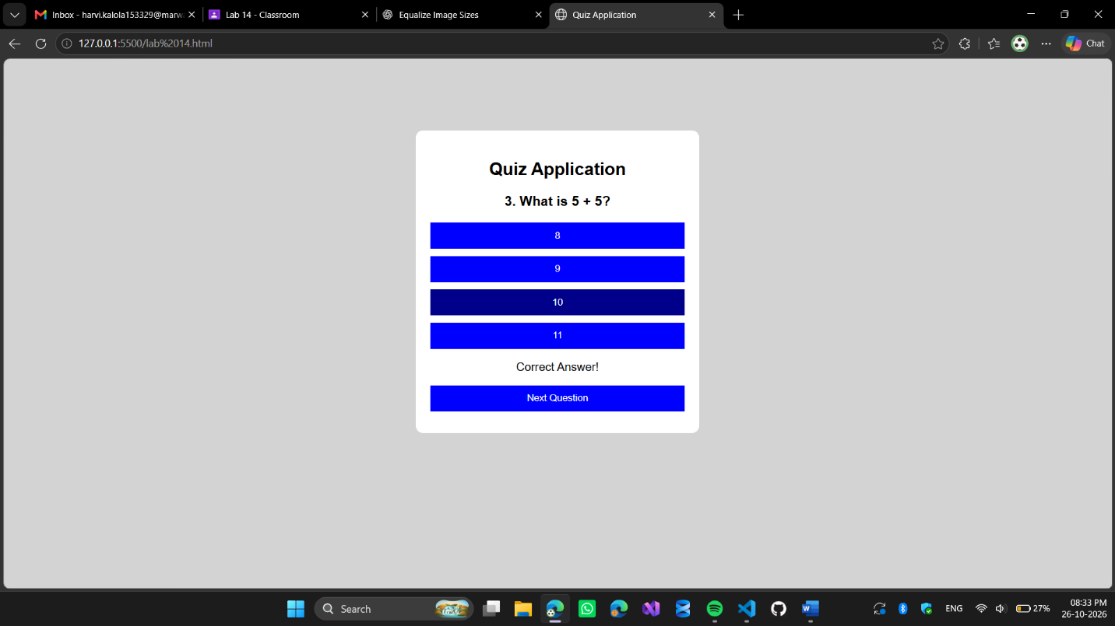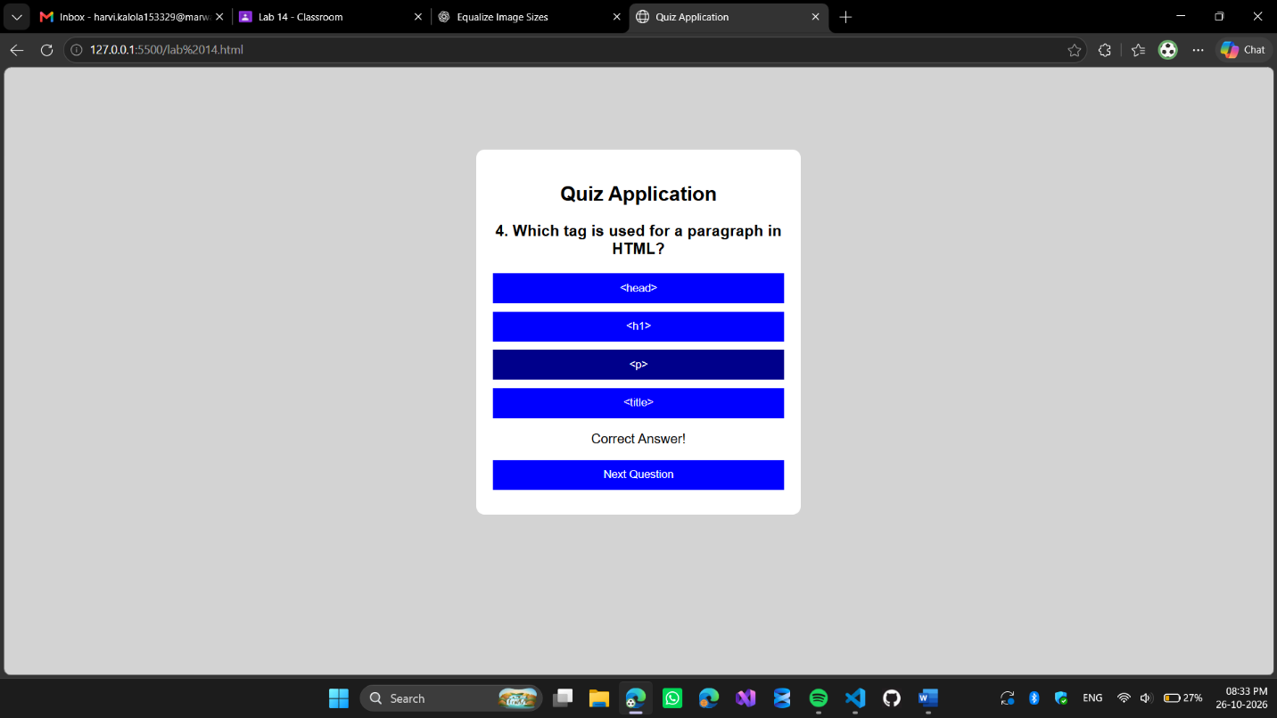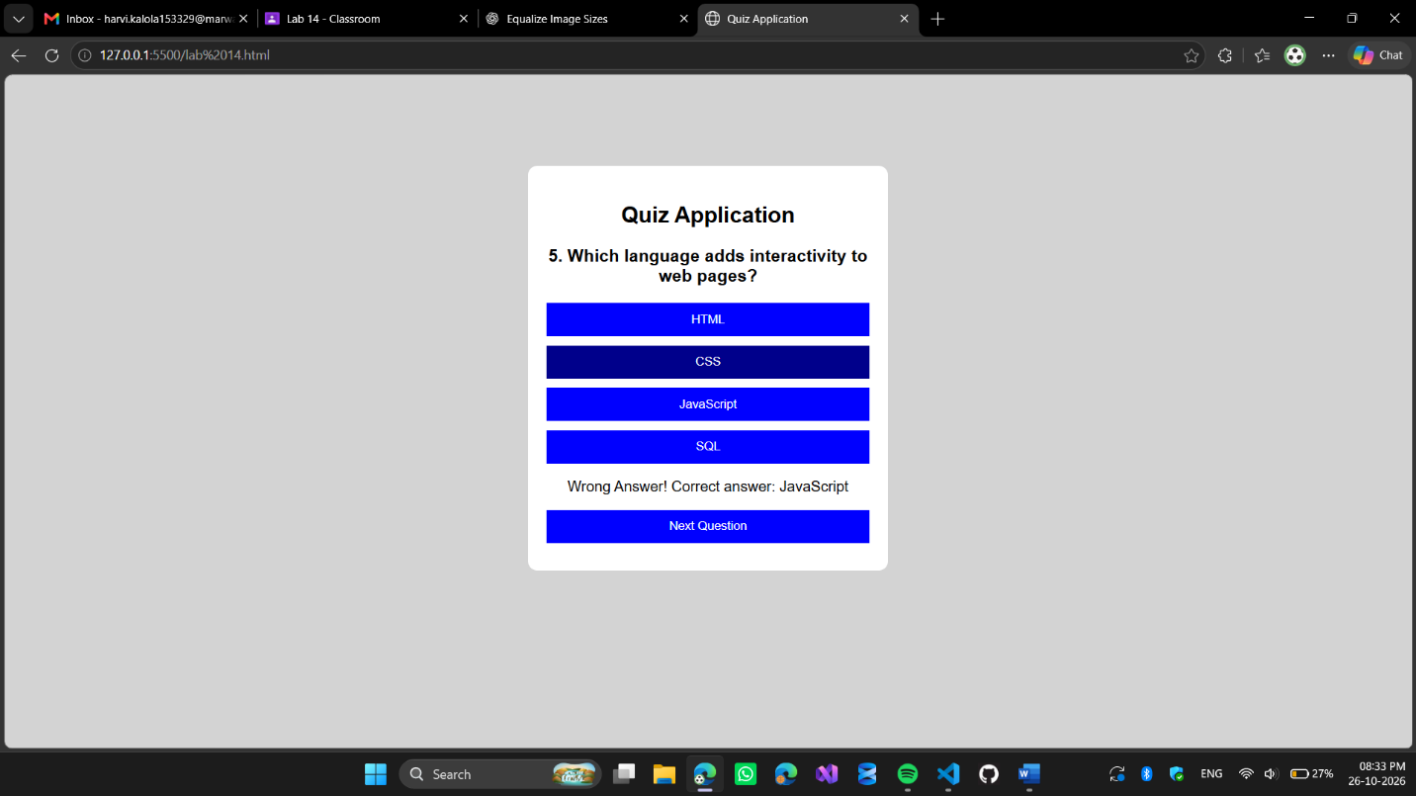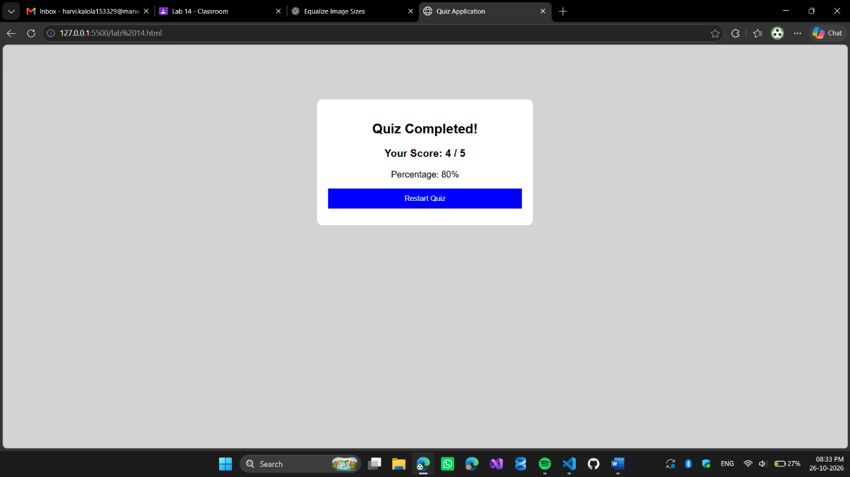

Code Snippet:

<!DOCTYPE html>
<html>
<head>
<title>Quiz Application</title>

<style>
body {
font-family: Arial;
background-color: lightgray;
text-align: center;
}

.quiz {
background-color: white;
width: 350px;
margin: 100px auto;
padding: 20px;
border-radius: 10px;
}

button {
display: block;
width: 100%;
padding: 10px;
margin: 10px 0;
background-color: blue;
color: white;
border: none;
cursor: pointer;
}

button:hover {
background-color: darkblue;
}
</style>
</head>

<body>

<div class="quiz">
<h2>Quiz Application</h2>

<h3 id="question"></h3>

<div id="options"></div>

<p id="result"></p>

<button id="next" onclick="nextQuestion()" style="display:none;">
Next Question
</button>
</div>

<script>
const questions = [
{
question: "1. What is the capital of India?",
options: ["Mumbai", "Delhi", "Chennai", "Kolkata"],
answer: "Delhi"
},
{
question: "2. Which language is used for web pages?",
options: ["HTML", "C", "Java", "Python"],
answer: "HTML"
},
{
question: "3. What is 5 + 5?",
options: ["8", "9", "10", "11"],
answer: "10"
},
{
question: "4. Which tag is used for a paragraph in HTML?",
options: ["&lt;head&gt;", "&lt;h1&gt;", "&lt;p&gt;", "&lt;title&gt;"],
answer: "&lt;p&gt;"
},
{
question: "5. Which language adds interactivity to web pages?",
options: ["HTML", "CSS", "JavaScript", "SQL"],
answer: "JavaScript"
}
];

let currentQuestion = 0;
let score = 0;

function showQuestion() {
document.getElementById("result").innerHTML = "";

let q = questions[currentQuestion];

document.getElementById("question").innerHTML = q.question;

let output = "";

q.options.forEach(function(option) {
output += `<button onclick="checkAnswer(this)">${option}</button>`;
});

document.getElementById("options").innerHTML = output;
}

function checkAnswer(button) {
let q = questions[currentQuestion];

if (button.innerHTML === q.answer) {
score++;
document.getElementById("result").innerHTML = "Correct Answer!";
} else {
document.getElementById("result").innerHTML =
"Wrong Answer! Correct answer: " + q.answer;
}

// Disable all options after answering
let buttons = document.querySelectorAll("#options button");

buttons.forEach(function(btn) {
btn.disabled = true;
});

document.getElementById("next").style.display = "block";
}

function nextQuestion() {
currentQuestion++;

if (currentQuestion < questions.length) {
showQuestion();
document.getElementById("next").style.display = "none";
} else {
showResult();
}
}

function showResult() {
document.querySelector(".quiz").innerHTML =
"<h2>Quiz Completed!</h2>" +
"<h3>Your Score: " + score + " / " + questions.length + "</h3>" +
"<p>Percentage: " +
Math.round((score / questions.length) * 100) + "%</p>" +
"<button onclick='location.reload()'>Restart Quiz</button>";
}

showQuestion();
</script>

</body>
</html>

